Call for Papers:

2010 INFORMS Service Science Conference

Date:
7-10, July 2010
Venue:
National Taiwan University of Science and Technology, TAIPEI, TAIWAN
WEBSITE:
http://icss.ie.nthu.edu.tw/icss/

Topics include, but are not limited to
* Service Science
* Service Management and Marketing
* Service Engineering and Systems
* Service Economics
* Service Education
* Service Simulation
* Applications and Case Study

Important Days
- March 1, 2010 | Deadline for submission of either abstracts or full paper
- April 15, 2010 | Acceptance / Rejection notification
- May 22, 2010 | Final abstract / paper due

Keynote Speakers

Prof. Gavriel Salvendy |  | Prof. James M. Tien
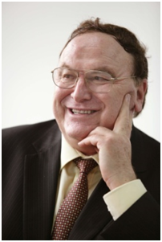 | Emeritus Professor  School of Industrial Engineering  Purdue University  West Lafayette , Indiana  Chair Professor and Head  Department of Industrial Engineering  Tsinghua University , P.R.China | 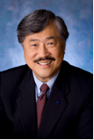 | Ph.D., D.Eng (h.c.), NAE  Distinguished Professor and Dean, College of Engineering  University of Miami,  Coral Gables, Florida

About SSC

- Conference Scope and Theme
Driven by a new business environment including global telecommunications, globalized economy, business automation, and business and technology innovations, the service sector keeps growing and now accounts for more than 50 percent of the labor force in the developed economies. It reaches as high as 80 percent in the United States and the United Kingdom. This unprecedented growth is changing the way companies organize themselves, resulting in a ripple effect in industries and universities with close ties to these organizations. With the shift in economic focus from manufacturing to service, industrial and academic research facilities now need to apply more scientific rigor to the practices of service, such as discovering better methods to use mathematical optimization to increase productivity and efficiency to meet the challenges.
To echo this shift to focusing on service, the INFORMS Service Science conference aims to provide a timely forum and bring together researchers and practitioners to discuss issues, identify challenges and future directions, and share their R&D findings and experiences in the areas of service science, management, and engineering. Papers relating to service quality control and improvement, service operations management, service design, innovations, marketing, and operations; logistics issues in services offerings, logistics as a service and related decision-making; service simulation; informatics-enabled service offerings, and information technology/systems services and related design, engineering, operations, and sustaining, etc. are strongly encouraged. Special sessions on specific service topics are also welcome.


